Chapter 10: Networking Fundamentals

Linux Systems Administration & Engineering Curriculum

Course Orientation
Attribute | Specification
Curriculum Position | Module 10 of 14
Allocated Duration | 2.5 to 3.0 Hours
Environment Target | Standard Ubuntu 22.04 / 24.04 LTS (Kernel 5.15+ / 6.8+)
Access Constraints | Non-Privileged Terminal Session (Zero-Sudo Policy)
Core Methodology | Layered Diagnostic Triangulation & Non-Destructive Inspection

Welcome to Chapter 10. As modern infrastructure shifts toward software-defined networks, distributed cloud topologies, and isolated container execution environments, systems administrators can no longer treat the operating system's networking stack as an opaque black box. An engineer who relies on superstition, random service restarts, or uncoordinated parameter tuning creates operational fragility and downtime.

This chapter provides a disciplined, bottom-up operational study of the Linux networking subsystem. In compliance with enterprise security posture and operational safety standards, all investigative patterns in this chapter adhere strictly to a zero-sudo policy. Network discovery, interface validation, route table inspection, local socket enumeration, and application health checks can—and must—be executed entirely using unprivileged, read-only utilities. You will master standard POSIX and modern Linux IP tooling (ip, ss, resolvectl, getent, ping, and curl), moving systematically across the protocol hierarchy to isolate root causes with mathematical certainty.

10.1 A Layered View of Network Communication
Network communication in Linux is architected around a hierarchical division of responsibilities known as the TCP/IP Model (RFC 1122). Unlike the theoretical seven-layer OSI model, the TCP/IP suite implements an engineering-focused four-layer architecture that maps directly to kernel data structures, device drivers, and userland runtimes.
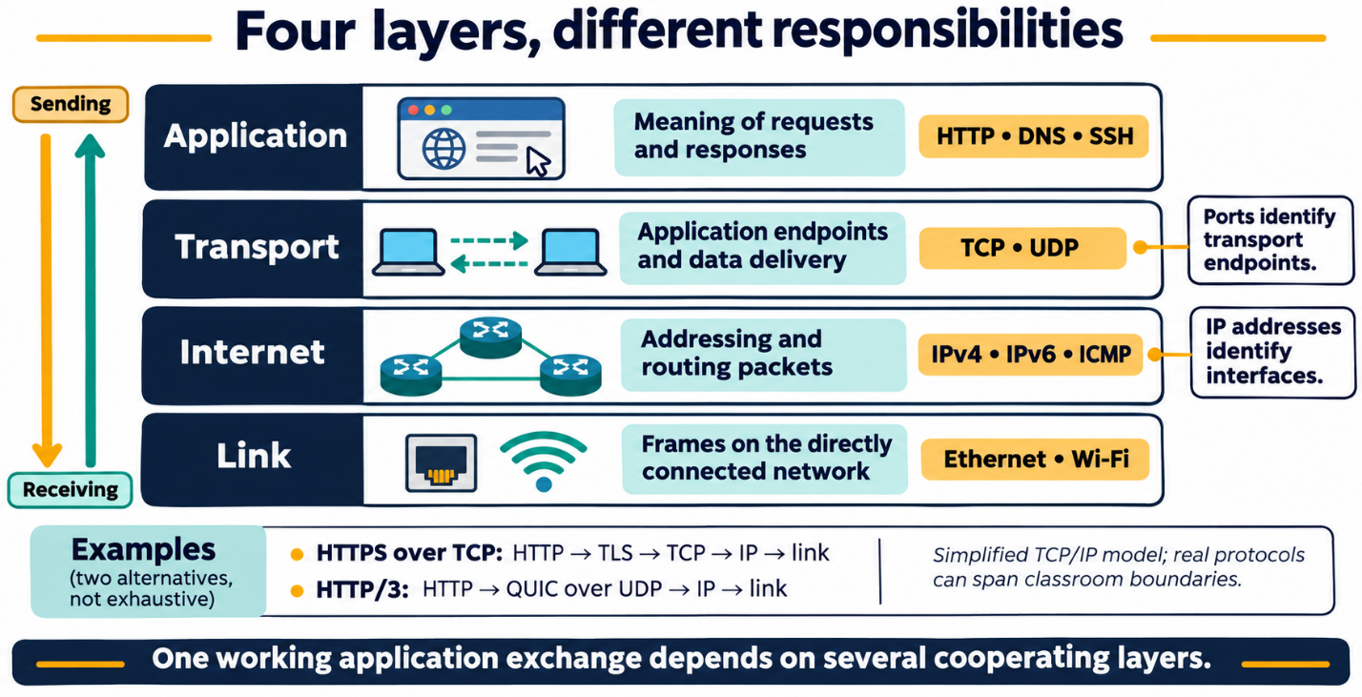

Figure 10.1: The 4-Layer TCP/IP Architectural Protocol Stack.

Layer Responsibilities and Protocol Mapping
- Link Layer (Layer 1): Directly communicates with physical or virtual network interface controllers (NICs). It governs frame encapsulation, local medium arbitration, and physical source/destination identification via 48-bit Media Access Control (MAC) addresses. Hardware drivers and kernel subroutines (like the virtual bridge driver) live here.
- Internet Layer (Layer 2): Solves the problem of inter-network host communication. Encapsulates transport segments into IP packets containing immutable source and destination logical IP addresses. It decides whether destination traffic is addressed to the local link or must be forwarded across intermediate hops via a gateway router.
- Transport Layer (Layer 3): Enables multiplexed, end-to-end communication between specific userland processes residing on different hosts. Operates using 16-bit integers called ports. Implements either stateful, connection-oriented, guaranteed-delivery streams (TCP) or stateless, lightweight message units (UDP).
- Application Layer (Layer 4): Directly consumes network data within user-space applications. Manages protocols such as DNS (port 53), SSH (port 22), HTTP (port 80), and HTTPS (port 443). The Linux kernel remains agnostic to the raw contents of Layer 4 payloads, acting solely as the transit engine.

The Asymmetric Nature of Layered Diagnostics
A disciplined systems engineer operates on two fundamental logical assertions:

- Lower-layer success does NOT guarantee application success: You may possess an active physical Ethernet link (Layer 1 UP), obtain a valid logical IP address (Layer 2 UP), and successfully exchange packets across intermediate routers (Layer 3/ICMP UP); however, if the remote daemon process crashed, bound to the wrong socket address, or encountered an internal database lockup, your HTTP request will fail instantly.
- Application-layer success PROVES lower-layer operational integrity: If an end-to-end application request successfully completes (such as a valid HTTP/1.1 200 OK header response returned from a remote server), you have deterministically proven that all underlying layers—frame framing, gateway routing, transport stream handshaking, and DNS name resolution—are functioning flawlessly for that specific communications channel.

10.2 Interfaces, Addresses, and Local Networks
The entry point into the operating system's networking stack is the network interface—a software abstraction exposed by the kernel representing physical hardware, virtualized hypervisor adapters, or logical software loops.

Interface Architectures
- Physical Adapters: Direct hardware components attached to the system bus (PCIe, USB). Modern Linux kernels use predictable device names based on firmware topologies and bus locations (e.g., enp3s0, eth0).
- Virtual Adapters: Software-defined interfaces instantiated by hypervisors, container runtimes, or network namespaces. Common prefixes include ens3 / vtnet0 (QEMU/KVM VirtIO), veth* (Docker/container veth pairs), and tun/tap (VPN tunneling).
- Loopback (lo): A purely virtual interface assigned the reserved IPv4 loopback network 127.0.0.0/8 (typically 127.0.0.1) and IPv6 ::1. Traffic routed to this interface never touches a physical NIC or local wire; it is immediately routed internally within the kernel's memory space back to the originating operating system.

Hardware vs. Logical Addressing
Every network interface capable of frame transmission possesses a permanent or hypervisor-assigned MAC address (e.g., 52:54:00:12:34:56), which functions as a physical identifier across the immediate local link.

Superimposed on the MAC address are Logical Addresses:

- IPv4 (32-bit): Expressed in dotted-decimal notation (e.g., 192.168.1.50).
- IPv6 (128-bit): Expressed in hexadecimal colon-separated groups (e.g., fe80::5054:ff:fe12:3456).

Network sizing and address space boundaries are designated using Classless Inter-Domain Routing (CIDR) notation. The CIDR prefix indicates the number of continuous leading bits allocated to identify the network segment, leaving the remaining bits to address specific host endpoints. For example, a /24 prefix allocates 24 bits to the network ID, providing $2^{(32 - 24)} - 2 = 254$ assignable host addresses on an IPv4 subnet.

Non-Privileged Inspection: ip link and ip address
Modern systems administration exclusively uses the iproute2 suite (ip), completely replacing the deprecated, obsolete ifconfig tool (which fails to display modern interface flags, multiple addresses per interface, and routing attributes correctly).

To inspect the physical data link state safely without superuser privileges:

ip link show

Sample output:

1: lo: <LOOPBACK,UP,LOWER_UP> mtu 65536 qdisc noqueue state UNKNOWN mode DEFAULT group default qlen 1000
link/loopback 00:00:00:00:00:00 brd 00:00:00:00:00:00
2: ens3: <BROADCAST,MULTICAST,UP,LOWER_UP> mtu 1500 qdisc fq_codel state UP mode DEFAULT group default qlen 1000
link/ether 52:54:00:9a:1b:2c brd ff:ff:ff:ff:ff:ff
altname enp0s3

Key indicators:

- <UP,LOWER_UP>: UP denotes the administrative state (the interface is enabled). LOWER_UP denotes the operational physical carrier state (the cable is plugged in or the virtual link layer is active).
- state UP: The link is ready for operational frame transmission.
- mtu 1500: Maximum Transmission Unit; the largest allowable frame payload size in bytes before packet fragmentation occurs.

To inspect the associated logical IP layer configurations without superuser privileges:

ip address show

Sample output:

1: lo: <LOOPBACK,UP,LOWER_UP> mtu 65536 qdisc noqueue state UNKNOWN group default qlen 1000
inet 127.0.0.1/8 scope host lo
valid_lft forever preferred_lft forever
inet6 ::1/128 scope host
valid_lft forever preferred_lft forever
2: ens3: <BROADCAST,MULTICAST,UP,LOWER_UP> mtu 1500 qdisc fq_codel state UP group default qlen 1000
inet 192.168.122.145/24 metric 100 brd 192.168.122.255 scope global dynamic ens3
valid_lft 3582sec preferred_lft 3582sec
inet6 fe80::5054:ff:fe9a:1b2c/64 scope link
valid_lft forever preferred_lft forever

10.3 Subnets, Routes, and the Default Gateway
When an application attempts to transmit an IP packet to a target destination IP, the Linux kernel must make an immediate routing determination:

- Is the destination address located on the local broadcast subnet directly attached to one of the system's own interfaces?
- Or is the destination located on an external/remote network, requiring the packet to be forwarded across an intermediate routing device?

The Subnet Boundary
Consider an interface configured with IP 192.168.122.145/24. The /24 netmask (255.255.255.0) declares that any IP falling between 192.168.122.1 and 192.168.122.254 resides on the same direct Layer 2 broadcast domain.

- Local Delivery: When sending traffic to 192.168.122.180, the kernel bypasses all routers. It uses the Address Resolution Protocol (ARP) or IPv6 Neighbor Discovery (ND) to determine the recipient's direct MAC address, encapsulates the packet inside a local Ethernet frame, and places it directly onto the wire.
- Routed Delivery: When sending traffic to 93.184.216.34, the kernel realizes this IP falls outside the local /24 subnet. It cannot communicate directly with that host at the link layer. It must hand the frame over to an intermediary router: the Default Gateway.
[ Host: 192.168.122.145/24 ]
|
+--- (Local Subnet: 192.168.122.0/24) --- Direct Link Delivery
|
[ Default Gateway: 192.168.122.1 ]
|
(Internet)
|
[ Destination: 93.184.216.34 ]

Figure 10.2: Local Direct Link Delivery vs. Routed Gateway Forwarding.

Inspecting the Kernel Routing Table
The kernel maintains an in-memory routing table consulted for every outbound packet. Inspect this table using:h
ip route show

Sample output:
```text
default via 192.168.122.1 dev ens3 proto dhcp src 192.168.122.145 metric 100
192.168.122.0/24 dev ens3 proto kernel scope link src 192.168.122.145 metric 100

Deconstructing the Routing Rules
- 192.168.122.0/24 dev ens3... scope link: This tells the kernel that any traffic targeted to addresses within 192.168.122.0/24 is directly reachable on the physical link (scope link) through interface ens3. No intermediate router is used.
- default via 192.168.122.1 dev ens3: The Default Route (conceptually matching 0.0.0.0/0). This rule matches all packets that do not satisfy any more-specific subnet routes. It commands the kernel: "Forward the packet to the next-hop router at IP 192.168.122.1 via device ens3."

Critical Architectural Insight: The Default Route Illusion
A frequent misconception among novice administrators is assuming that because ip route show displays an active default via ... entry, the host possesses functioning Internet access.

The presence of a default route proves only that a local configuration rule exists in the kernel. It confirms where the operating system will attempt to forward off-subnet packets. It does not prove that:

- The gateway router at 192.168.122.1 is powered on or reachable.
- The gateway is willing to forward transit traffic.
- Upstream WAN or ISP connections beyond the gateway are operating.

10.4 Name Resolution and the DNS Lookup Path
Humans navigate services via human-readable Fully Qualified Domain Names (FQDNs), such as api.internal.net or example.com. However, the Internet Layer routes traffic exclusively via numerical IP addresses. The translation mechanism that reconciles this divergence is the Domain Name System (DNS).

The Linux Resolution Sequence
When a Linux application requests a network connection to a hostname, the C standard library (glibc) executes a standardized resolution routine governed by /etc/nsswitch.conf:

+--------------------------------------------------------------+
| Process initiates lookup for "service.internal" |
+--------------------------------------------------------------+
|
v
+--------------------------------------------------------------+
| Step 1: Query Local Static Files (/etc/hosts) |
| If matched, return hardcoded IP immediately. |
+--------------------------------------------------------------+
| (No match)
v
+--------------------------------------------------------------+
| Step 2: Query Local Resolver Stub Daemon |
| Contact 127.0.0.53:53 (systemd-resolved) via /etc/resolv.conf|
+--------------------------------------------------------------+
| (Cache miss)
v
+--------------------------------------------------------------+
| Step 3: Query Upstream DNS Resolvers |
| systemd-resolved queries authoritative or recursive DNS |
| servers configured via DHCP or static link configs. |
+--------------------------------------------------------------+

- Static Table (/etc/hosts): A simple flat configuration file mapping IP addresses to names. This is always evaluated first by default. If an entry exists here, the operating system bypasses network DNS queries entirely.
- Local Caching Resolver Stub (systemd-resolved): On modern Ubuntu installations, /etc/resolv.conf points to 127.0.0.53. This is a local loopback listener managed by the systemd-resolved system service, which provides client-side query caching and manages upstream DNS endpoints dynamically.
- Upstream Recursive Nameservers: If systemd-resolved does not have the record cached locally, it dispatches an outbound UDP/TCP port 53 query to the configured upstream nameservers (such as enterprise directory servers or cloud resolvers like 8.8.8.8 or 1.1.1.1).

Non-Privileged Name Resolution Queries
To test hostname resolution exactly as modern system services see it, use the Name Service Switch lookup tool:
getent hosts example.com
Sample output:
93.184.216.34 example.com

To view comprehensive systemd DNS status, configured upstream nameservers, query latency, and cache metrics:

resolvectl status

To execute an explicit, non-privileged diagnostic query against the local resolver stub:
resolvectl query example.com

Sample output:
example.com: 93.184.216.34 -- link: ens3
2606:2800:220:1:248:1893:25c8:1946 -- link: ens3

-- Information acquired via protocol DNS in 14.2ms.
-- Data is authenticated: no; options: NONE

Isolating Name Resolution Failures vs. Transport Failures

A critical diagnostic rule: Never attempt application-level troubleshooting until you have decoupled name resolution from transport connectivity.

If an application reports `Connection Refused` or `Could not resolve host`:
- Execute `getent hosts <target-domain>`. If this returns nothing or outputs `Host not found`, the failure lives exclusively in your DNS path (Layer 4 Application/DNS). The physical interfaces, gateway routes, and remote host may be entirely healthy, but the application cannot proceed because it does not know where to direct packets.
- If `getent hosts <target-domain>` immediately returns a valid IP address, DNS is operating correctly. Any downstream connection failures must stem from transport routing, firewall blocks, or unresponsive application processes.

10.5 Ports, Sockets, and Transport Protocols

Once an IP packet reaches the target operating system, the kernel must deliver its payload to the specific user-space process responsible for handling it. This demultiplexing process occurs at Layer 3 (Transport Layer) using Ports.

A Socket represents an active communication endpoint within the kernel, uniquely defined by a 5-tuple:
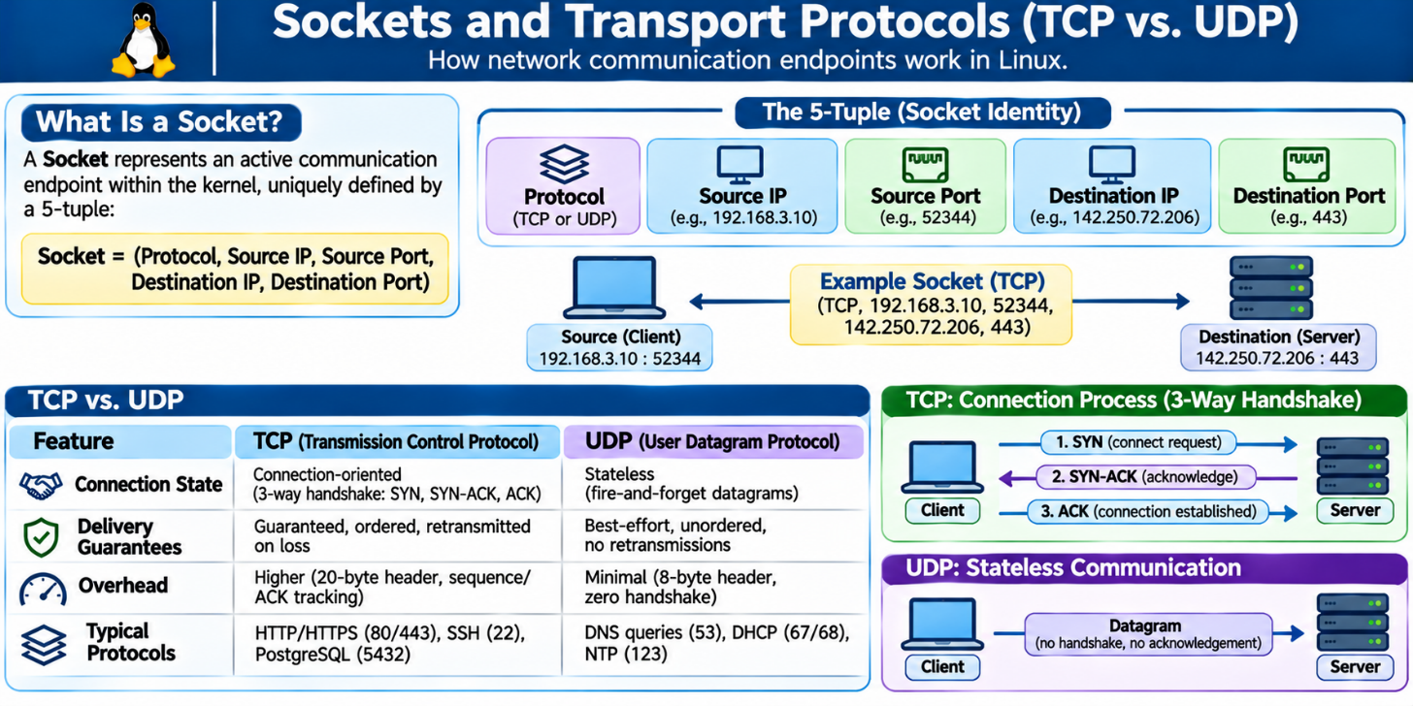

Common Standardized Ports

- 22/TCP: Secure Shell (SSH) Remote Administrative Access
- 53/UDP & TCP`: Domain Name System (DNS)
- 80/TCP: Hypertext Transfer Protocol (HTTP)
- 443/TCP: Hypertext Transfer Protocol Secure (HTTPS)

Listening Sockets and Bind Addresses

Server software (such as Nginx, Apache, or OpenSSH) instructs the kernel to open a Listening Socket bound to a specific local IP address and port. The chosen bind address defines the listening scope:

- 127.0.0.1:8080: The process is bound exclusively to the local loopback interface. It will accept incoming requests originating from the local machine only. It is completely inaccessible to external machines across the network, regardless of firewall settings.
- 0.0.0.0:80: The wildcard IPv4 address (`INADDR_ANY`). The process is listening on all available network interfaces. It will accept traffic arriving across any physical, virtual, or loopback link.
- 192.168.122.145:80: The process is bound strictly to a single physical interface. It will ignore traffic arriving via other interfaces or loopback.

Inspecting Local Sockets with `ss -tuln`

The modern Linux standard for socket inspection is `ss` (Socket Statistics), which supersedes the obsolete `netstat` command by pulling state directly from kernel `netlink` structures.

To execute a non-privileged, read-only audit of all listening endpoints:
ss -tuln

Flag breakdown:

- -t: Display TCP sockets.
- -u: Display UDP sockets.
- -l: Show only sockets currently in the LISTEN state (omits transient client connections).
- -n: Show numeric port and address numbers (avoids slow reverse-DNS resolution of IPs and services).

Sample output:

Netid State Recv-Q Send-Q Local Address:Port Peer Address:Port Process
udp UNCONN 0 0 127.0.0.53%lo:53 0.0.0.0:*
tcp LISTEN 0 128 0.0.0.0:22 0.0.0.0:*
tcp LISTEN 0 511 127.0.0.1:8080 0.0.0.0:*
tcp LISTEN 0 128 [::]:22 [::]:*

Interpretation:

- Row 1: systemd-resolved listening locally on 127.0.0.53:53 for UDP DNS requests.
- Row 2: SSH listening on all IPv4 interfaces (0.0.0.0:22).
- Row 3: A web service listening on port 8080 bound exclusively to loopback (127.0.0.1:8080). External systems cannot access this service.
- Row 4: SSH listening on all IPv6 interfaces ([::]:22).

10.6 Bounded Reachability Checks with ping
The ping utility provides low-level connectivity diagnostics operating over the Internet Control Message Protocol (ICMP). It sends an ICMP Echo Request (Type 8) to a target IP and awaits an ICMP Echo Reply (Type 0).

The Unbounded Execution Hazard
In Unix and Linux environments, executing ping <target> without arguments causes the program to transmit packets indefinitely until manually interrupted via SIGINT (Ctrl+C).

CRITICAL LAB & PRODUCTION DIRECTIVE:
NEVER execute unbound ping commands. In automated scripts, cron jobs, or CI/CD
pipelines, an unbounded ping causes infinite process hanging, thread exhaustion,
and pipeline deadlocks. Always enforce explicit termination using the count flag:
ping -c 4 <target>

Sample bounded command:

ping -c 4 192.168.122.1

Sample output:

PING 192.168.122.1 (192.168.122.1) 56(84) bytes of data.
64 bytes from 192.168.122.1: icmp_seq=1 ttl=64 time=0.342 ms
64 bytes from 192.168.122.1: icmp_seq=2 ttl=64 time=0.298 ms
64 bytes from 192.168.122.1: icmp_seq=3 ttl=64 time=0.312 ms
64 bytes from 192.168.122.1: icmp_seq=4 ttl=64 time=0.285 ms

--- 192.168.122.1 ping statistics ---
4 packets transmitted, 4 received, 0% packet loss, time 3072ms
rtt min/avg/max/mdev = 0.285/0.309/0.342/0.021 ms

Diagnostic metrics to evaluate:

- Packet Loss Percentage: Any loss above 0% indicates physical link degradation, router queue saturation, or intermediate wireless interference.
- Round-Trip Time (RTT): time=... ms indicates latency. Drastic variance between minimum and maximum RTT indicates network jitter.

The Ping Trap: When 100% Packet Loss Proves Nothing
A widespread systems engineering error is concluding that a target host is down, powered off, or unreachable simply because ping -c 4 <target> reports 100% packet loss:t
--- target.internal ping statistics ---
4 packets transmited, 0 received, 100% packet loss, time 3102ms

ICMP is an auxiliary management protocol, not an application protocol. Network firewalls, cloud security groups (e.g., AWS Security Groups, Azure Network Security Groups), and host firewalls (`iptables`, `nftables`, Windows Defender Firewall) are routinely configured to drop inbound ICMP Echo Requests silently to prevent network scanning and reconnaissance.

Diagnostic Principle:
- Successful ICMP ping responses prove that Layer 1, Layer 2, and Layer 3 reachability are functional.
- Unsuccessful ICMP ping responses prove only that the target is not answering ICMP requests. The target host may be fully operational, running an accessible web server or database behind an ICMP-filtering firewall. Never use `ping` as the sole determinant of service health.

10.7 Application Probing with `curl -I`

To validate Layer 4 Application Layer reachability safely and deterministically, systems engineers employ curl. When probing web endpoints, downloading multi-gigabyte HTML payloads or binary media streams is inefficient and generates unnecessary load. Instead, use an HTTP `HEAD` request to inspect response headers without downloading the body.

Safe Inspection Flags

-I (--head): Sends an HTTP `HEAD` request instead of `GET`. The remote server executes standard routing and authentication pipelines, returning only the HTTP status line and response headers.
--max-time <seconds>: Enforces a hard timeout deadline. If a target network black-holes traffic or drops packets without sending a TCP `RST`, standard connection attempts can hang for minutes. Always enforce a bounded timeout (e.g., `--max-time 10`).

Sample execution:
curl -I --max-time 10 http://example.com

Sample output:
HTTP/1.1 200 OK
Age: 521873
Cache-Control: max-age=604800
Content-Type: text/html; charset=UTF-8
Date: Mon, 15 Jan 2024 10:00:00 GMT
Etag: "3147526947+ident"
Expires: Mon, 22 Jan 2024 10:00:00 GMT
Last-Modified: Thu, 17 Oct 2019 07:18:26 GMT
Server: ECS (dcb/7ea3)
Vary: Accept-Encoding
Content-Length: 1256

Decoding HTTP Status Codes
The first line of the output contains the HTTP status code, which isolates application state:

Status Code Series | Semantic Category | Operational Meaning
200 OK | Success | Full Layer 1–4 success. Application operational.
301 / 302 | Redirection | The resource has migrated. Follow target URL in Location: header.
401 / 403 | Client Error | Access denied. Authentication missing or unauthorized.
404 Not Found | Client Error | Routing and server up; the requested URI path does not exist.
500 Internal | Server Error | Network up; the backend application process crashed or failed internally.
502 / 503 | Gateway Error | Web server reachable; upstream app server or reverse proxy is dead.

Diagnostic Truth: Error Codes Equal Reachability Success
From a network engineering perspective: Receiving an HTTP 403 Forbidden, 404 Not Found, or 500 Internal Server Error is a conclusive network success.

To generate a 500 Internal Server Error, the local client had to:

- Resolve the DNS hostname to an IP address.
- Route packets through the default gateway across the Internet.
- Establish a stateful 3-way TCP handshake on port 80/443.
- Deliver an HTTP request payload to the remote user-space process.

The failure is strictly semantic within the remote application. Your network stack functions completely.

10.8 The Layered Troubleshooting Workflow
When troubleshooting network incidents, avoid random, uncoordinated commands. Follow a rigorous, deterministic 5-Stage Diagnostic Sequence. This methodology systematically traverses the protocol stack from the local kernel outward to the remote application.
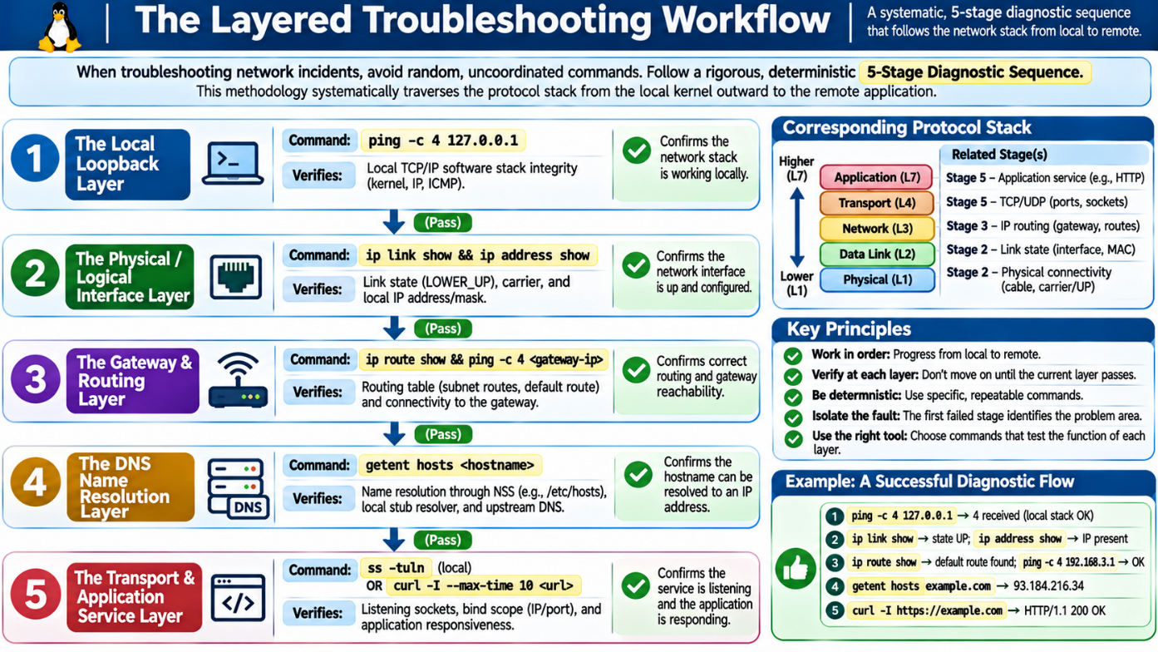
Figure 10.3: The Standard 5-Stage Network Diagnostic Workflow.

Engineering Rule: Separate Observation from Inference
A professional systems engineer maintains strict boundaries between raw experimental evidence and hypothetical interpretation:

- Observation (Fact): "Executing ping -c 4 192.168.122.1 resulted in 0 packets received, 100% packet loss over a duration of 3100ms."
- Inference (Hypothesis): "The gateway router is offline, or an intermediate firewall is filtering ICMP Echo requests."

Never state your inferences as facts. Record the concrete output first, document any uncertainty, and confirm your hypothesis using independent secondary diagnostic tools (e.g., verifying with curl or port checks when ICMP fails).

10.9 Hands-On Student Lab: Diagnose a Connectivity Path

Lab Objectives & Safety Protocols
- Safety Mandate: All tasks must be completed without superuser privileges (no sudo).
- Target Environment: Standard unprivileged terminal shell on an Ubuntu LTS host.
- Objective: Execute an end-to-end, read-only diagnostic trace of your local network environment, evaluate gateway routing, confirm resolver integrity, inspect local listeners, and validate remote application reachability.

Part A: Interface & Physical Link Audit
- Execute the link discovery command to identify your active interfaces and physical link status:
ip link show

- Execute the address discovery command to identify your assigned IP addresses and CIDR subnet masks:
ip address show

- Data Recording: Locate your primary non-loopback network interface (e.g., ens3, eth0). Record:
  - Interface Name: ________________________
  - Operational State (e.g., UP, DOWN): ________________________
  - MAC Address (link/ether): ________________________
  - Assigned IPv4 Address with CIDR: ________________________

Part B: Routing Table & Gateway Inspection
- Query the operating system's routing table:
ip route show

- Data Recording:
  - What is the destination network of your direct link route? ________________________
  - What is the IP address of your configured Default Gateway? ________________________
  - What device interface handles the default route? ________________________

Part C: Loopback & Gateway Bounded Probing
- Verify the integrity of your local kernel's internal networking stack by pinging loopback:
ping -c 4 127.0.0.1

- Ping your default gateway IP address (identified in Part B) using a bounded check:
ping -c 4 <gateway-ip>

- Data Recording:
  - Loopback Packet Loss %: ___________ Average RTT: ___________ ms
  - Gateway Packet Loss %: ___________ Average RTT: ___________ ms

Part D: DNS Lookup Path Validation
- Query name resolution for the target domain example.com using the Name Service Switch:
getent hosts example.com

- Query the active resolver configuration using systemd-resolved:
resolvectl query example.com

- Data Recording:
  - Resolved IPv4 Address: ________________________
  - Which resolver protocol and link responded to the query? ________________________

Part E: Socket Inspection & Application Probing
- Inspect all listening sockets on your local operating system:
ss -tuln

- Identify whether any service is bound to wildcard 0.0.0.0 or strictly to loopback 127.0.0.1.
- Dispatch a safe, bounded application-layer probe to example.com:
curl -I --max-time 10 http://example.com

- Data Recording:
  - Record the HTTP Status Response line: ________________________
  - Record the Server or Content-Type header: ________________________

Part F: Evidence-Based Diagnostic Synthesis
Synthesize your experimental data from Parts A through E into a structured diagnostic summary:t
DIAGNOSTIC EVIDENCE REPORT
- Local Host Link State:
[ ] Interface UP / Carrier Active [ ] Interface DOWN / Disconnected
- Routing Assessment:
[ ] Default Route Present [ ] Default Route Missing
Gateway Address: __________________________________________________
- Lower-Layer Reachability (ICMP):
Loopback Reachable: [ ] YES [ ] NO
Gateway Reachable: [ ] YES [ ] NO (If NO, note ICMP filtering uncertainty)
- Name Resolution Assessment:
DNS Resolution Successful: [ ] YES [ ] NO
Target IP Resolved: _______________________________________________
- Application Reachability (HTTP HEAD):
HTTP Status Code Received: ________________________________________
Conclusion: [ ] Application Path Fully Verified
[ ] Layer 4 Transport / Semantic Failure
======================================================================

10.10 Chapter Key Terms Glossary

1. Loopback (lo): A virtual network interface implemented entirely within the kernel's software architecture (127.0.0.1`, `::1), used for local process-to-process communication without routing traffic across physical network hardware.
2. Media Access Control (MAC) Address: A 48-bit unique hardware identifier burned into or assigned to a Network Interface Controller, operating exclusively at Layer 1 (Link Layer) for local-link frame delivery.
3. Classless Inter-Domain Routing (CIDR): A compact notation for IP addressing and subnet allocation, specifying the base IP address followed by a slash and the count of leading network bits (e.g., 192.168.1.0/24).
4. Default Gateway: The next-hop router designated in the host's routing table responsible for forwarding any outbound traffic addressed to destinations outside the local subnet.
5. Default Route: A fallback routing table rule (designated as default or 0.0.0.0/0` that matches all packets not explicitly handled by more specific subnet entries.
6. Domain Name System (DNS): A globally distributed, hierarchical database protocol mapping human-readable hostnames (FQDNs) to routable numerical IP addresses.
7. systemd-resolved: The standard Ubuntu/Linux local network name resolution management service, exposing an internal caching DNS stub resolver at 127.0.0.53:53.
8. Transmission Control Protocol (TCP): A connection-oriented, stateful transport-layer protocol providing reliable, sequenced, and error-checked byte streams via a 3-way handshake.
9. User Datagram Protocol (UDP): A lightweight, stateless, connectionless transport-layer protocol providing best-effort datagram delivery with minimal latency and header overhead.
10. Socket: An internal operating system communication endpoint uniquely defined by the 5-tuple: protocol, source IP, source port, destination IP, and destination port.
11. Internet Control Message Protocol (ICMP): A network-layer operational protocol used by diagnostic utilities like `ping` to transmit error messages and operational signaling (Echo Request/Reply).
12. Hypertext Transfer Protocol (HTTP) HEAD Request: An application-layer request method that retrieves the HTTP response headers identical to an HTTP GET request, but omits the transmission of the response body.

10.11 Review Questions

Concept Review Questions

1. Identify the four layers of the TCP/IP networking model and name at least one real-world protocol operating at each layer.
2. Explain the fundamental difference in operational scope between a Layer 1 MAC address and a Layer 2 IP address.
3. Why does modern Linux systems administration use the `ip` tool from the `iproute2` suite rather than the legacy `ifconfig` command?
4. In the output of `ip link show`, distinguish between the administrative link status and the operational carrier status indicated by <UP,LOWER_UP>.
5. What does the CIDR suffix /24 signify regarding available host addresses within an IPv4 network segment?
6. Describe the decision process the Linux kernel executes when evaluating whether an outbound packet requires transmission to the Default Gateway.
7. A junior administrator inspects a routing table, sees default via 10.0.0.1 dev eth0, and concludes that external Internet connectivity is confirmed. Explain why this conclusion is logically invalid.
8. Outline the three-step sequence the Linux name resolution subsystem executes when an unprivileged user process requests a hostname lookup.
9. What is the specific architectural role of the IP address 127.0.0.53 on an Ubuntu operating system?
10. If getent hosts internal.corp returns no data, explain why attempting to debug an application error using curl is premature.
11. Contrast the operational characteristics of TCP and UDP. Why is DNS resolution typically conducted over UDP, whereas SSH requires TCP?
12. Define a network socket. What specific data values constitute the socket 5-tuple?
13. If an engineer binds an internal database service to 127.0.0.1:3306, can an administrator connect to this database from an external workstation across the local LAN? Explain why or why not.
14. What does the wildcard address 0.0.0.0 represent when observed in the local listening address column of `ss -tuln`?
15. Explain why executing an unbounded `ping` command inside an automated deployment script is dangerous. What flag mitigates this risk?
16. Describe the mechanical exchange involved in an ICMP connectivity check.
17. Explain "The Ping Trap." If a target server displays 100% packet loss during a bounded `ping` test, does this prove that the host is offline? Justify your answer.
18. What specific command-line arguments allow `curl` to inspect HTTP response status without downloading the associated webpage content?
19. Why is a `--max-time` boundary essential when automating diagnostic checks with `curl`?
20. A connectivity check using curl -I returns HTTP/1.1 500 Internal Server Error. Does this output indicate a network infrastructure failure or an application failure? Explain the evidence.
21. What diagnostic conclusion can be drawn if curl -I returns an HTTP `403 Forbidden` response?
22. Outline the 5-Stage Network Diagnostic Workflow in proper sequence.
23. Why must testing the local loopback interface (127.0.0.1) precede testing external gateway reachability?
24. Explain the difference between an empirical observation and an inference within a systems troubleshooting context.
25. Under enterprise security policies, why is a zero-sudo diagnostic policy preferred when investigating network infrastructure incidents?

Lab Reflection Questions

1. In Part A of the lab, did your primary network interface list an altname? What is the engineering purpose of predictable alternative interface naming in Linux?
2. When inspecting ip route show in Part B, how many distinct routes existed in your table? Identify which route possessed the highest specificity (longest prefix match).
3. In Part C, what was the measured round-trip time (RTT) variance to your gateway compared to the local loopback interface? What causes this difference?
4. In Part D, compare the information returned by getent hosts versus resolvectl query. Which utility provides deeper insight into protocol timing and interface binding?
5. During Part E, did ss -tuln reveal any sockets bound strictly to 127.0.0.1? If a service bound to 127.0.0.1 needs to be accessed by external clients, what reconfiguration is required?
6. You are dispatched to resolve a production incident where users cannot access a web application. Using the 5-Stage Diagnostic Workflow, describe the exact series of commands you would execute, the expected outputs, and how you would isolate whether the failure is DNS-related, routing-related, or application-related without using sudo.

